SAP CX offers the functionality for delivery modes using a fixed table. Provide a solution for customizing it in order to integrate with an external Transportation Management System (TMS) SaaS for operations like:

Quoting freight price
Create the shipping order in the TMS

For the following scenario, a proposed model for integration with the external TMS system follows.

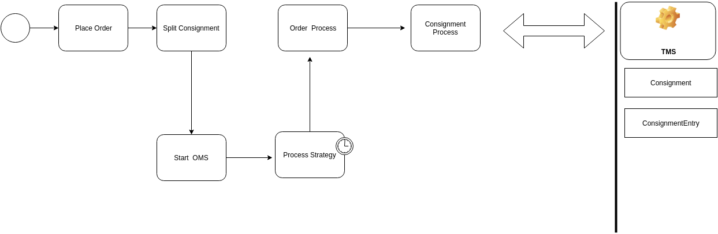
First, the execution of the payment order, to initiate the client shipment, and to make an architecture to start the OMS in a synchronous way, guaranteeing all the security steps, until arriving at the point where we would make a REST call, with the consignment data.

Consignment :

- Delivery Cost
- Estimated Delivery
- Total price
- Type of Delivery
- Delivery address
- Shipping status

ConsignmentEntry :

- Amount
- Delivery Cost per unit
- Price per unit

